 

## Department of Electrical and Electronic Engineering

## CPT109 C Programming and Software Engineering 1

### CPT109 C Programming Report

#### Name : Tiankuo.Jiao Student ID : 1929098

**Catalogue**

Exercise 1 3

Specification（Problem statement） 3

Analysis： 3

Flow chart 4

Design 5

Testing 6

Exercise 2 7

Specification（Problem statement） 7

Analysis： 7

Flow chart 8

Design 9

Testing 10

Exercise 3 11

Specification（Problem statement） 11

Analysis： 12

Flow chart 13

Design 14

Testing 15

Exercise 4 16

Specification（Problem statement） 16

Analysis： 16

Flow chart 17

Design 18

Testing 19

Implementation 20

# Exercise 1

**Specification（Problem statement）:**

The task is to let the user enter a full name with spaces (e.g. Jet Li) from the keyboard.Add together the character values of the name entered and print the total on the screen. (e.g. Jet Li = 74 + 101 + 116 + 76 + 105 = 472).Therefore,this program provides the following functions:

1. The user can enter a full name with spaces from the keyboard
2. After the user to enter a full name, reading each character to see if it is a letter. an error condition is as follows:
3. The user enters a number in a name ,e.g.Jet Li1
4. The user enters a full name without spaces，e.g.JetLi
5. The user enters a full name without strange character，e.g.JetLi&
6. The output result of the program is the sum of the ASCII values of the name
7. The program exits.

**Analysis：**

The question asks the user to enter a full name with a space, but the user may enter the digits incorrectly, causing the program to fail. Therefore, it is necessary to consider how to solve this problem. The error reporting cases mainly include the above three points. It is necessary to judge whether the user has entered the correct characters.

**Flow chart :**

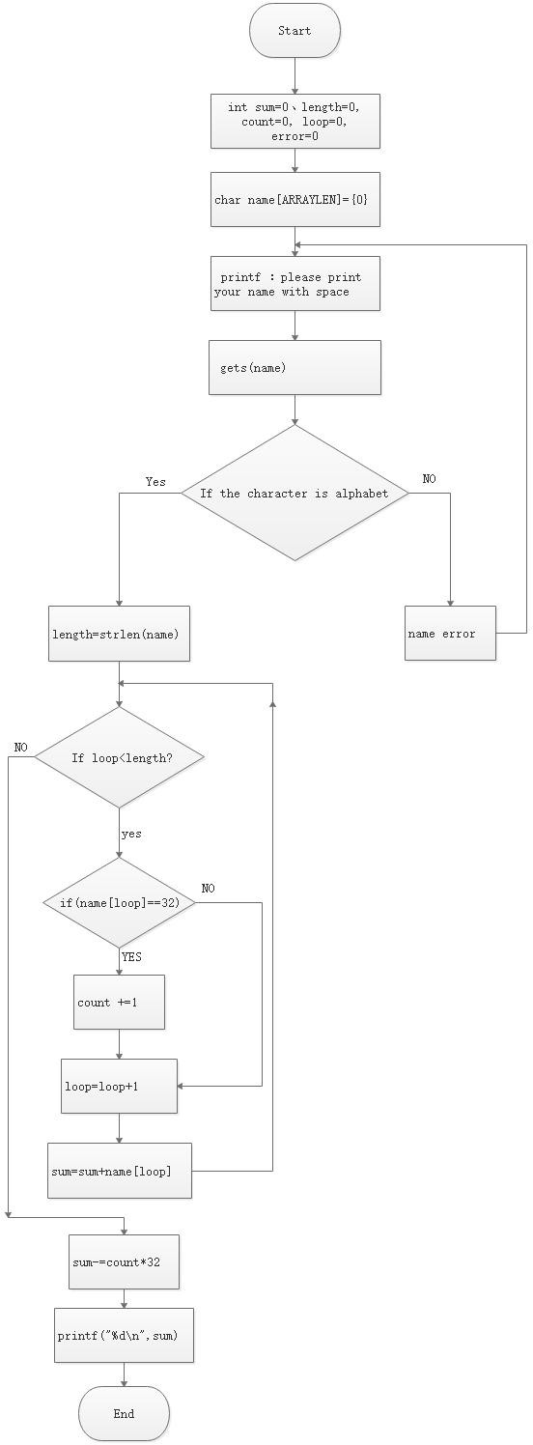

##### On an input:

The message “please print your name with space: ”is printed on the screen to let the users know what data this program need.

##### On Outputs:

The output is the sum of the ASCII codes represented by each letter(without space)

##### Data structure:

The input data structure is letters, and the output is the sum of the ASCII codes represented by each letter.

##### Algorithm:

length=strlen(name); for(loop=0;loop<length;loop++){

if(name[loop]==32)/*Count the number of spaces*/ count +=1;

sum=sum+name[loop];

}

sum-=count*32;/*Subtract the value represented by the space*/ printf("%d\n",sum);

**Design**

1. Declare an array: name, four variables of type “int”

Name them appropriately , respectively:

Int loop-Add a variable that will increase during the loop Int error - Error=1 means the program will continue count- the number of space

length-The length of the name

1. Print a message “please print your name with space: ”on the screen to ask the user to input the name.
2. Read the input name from the keyboard.
3. The program is terminated if the read fails. (Judge if the input is a name) 5.Print a message “please print your name with space: ”on the screen to

ask the user to input eleven real number again.

1. Cycle computing each letter including Spaces ASCII value
2. Multiply the total minus the number of Spaces times 32.
3. Display the result on the screen (sum).

**Testing**

Test 1

Enter the right name with space: For example: Tiankuo Jiao. Test result:1118

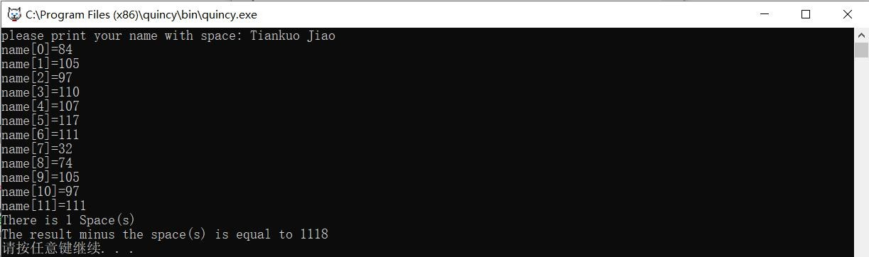

Test 2

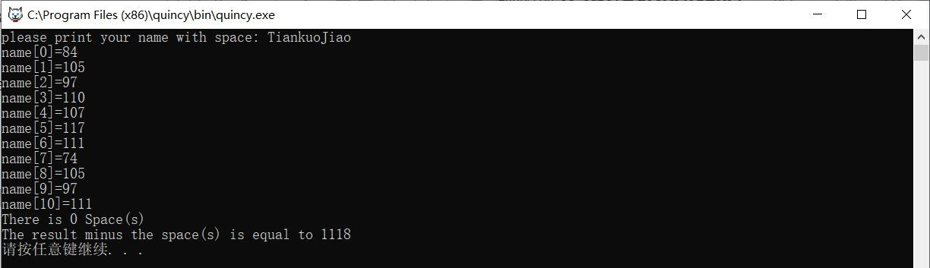Enter the right name without space: For example: TiankuoJiao. Test result:1118

Test 3

Enter the wrong name with number: For example: Tiankuo Jiao1. Test result:name error

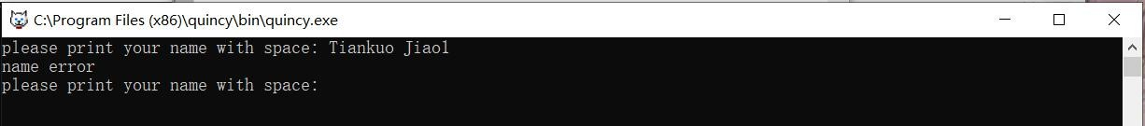

Test 4

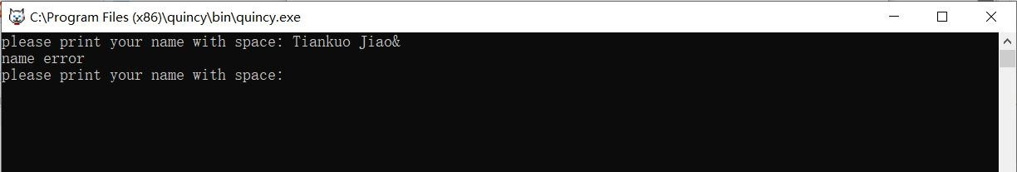Enter the wrong name with strange character: For example: Tiankuo Jiao&. Test result:name error

Test 5

Enter the wrong name with strange character without space: For example: TiankuoJiao&.

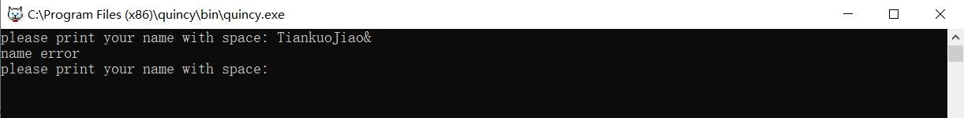Test result:name error

# Exercise 2

**Specification（Problem statement）:**

The task is to let the user enter an 11-digit phone number and display the values of the first six digits divided by the next five digits on the screen. For example: Read a telephone number (e.g. 12345678900) and print the value on the screen (123456/78900 = 1.56).Therefore, this program provides the following functions:

1. The user can enter eleven digits in the interface.
2. After the user to enter the numbers, scanning each character and judge if it is Arabic numbers, an error condition is as follows:
3. The user enters a non-eleven-digit number, e.g. 123456789123
4. The user enters letters and other non-Arabic numerals,e.g.1234567891a (3)The user enters strange characters,e.g.1234567891&
5. The output result of the program is "% lf" double precision floating point data. Keeping six decimal places can ensure the error is minimal.
6. The program exits.

**Analysis：**

The question asks the user to enter eleven telephone numbers, but the user may enter the digits incorrectly, causing the program to fail. Therefore, it is necessary to consider how to solve this problem. The error reporting cases mainly include the above three points. It is necessary to judge whether the user has entered the correct number. The output data retains six decimal places.

**Flow chart :**

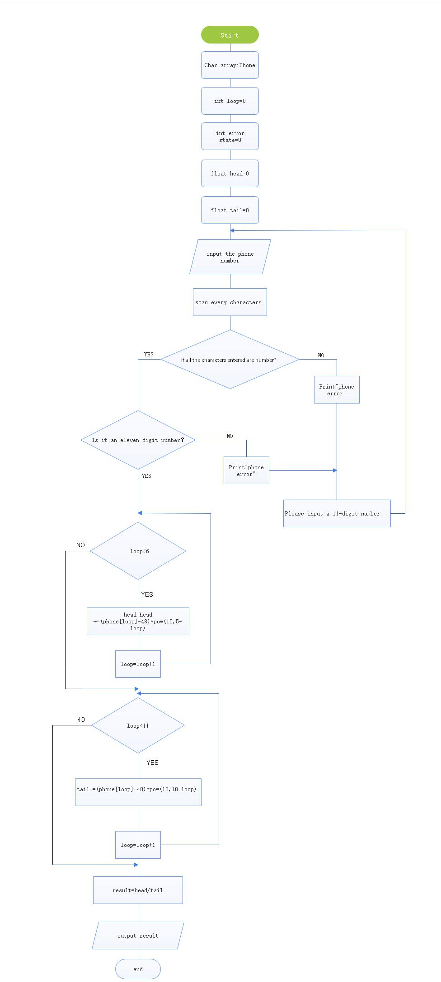

##### On an input:

The message “Please input a 11-digit number: ”is printed on the screen to let the users know what data this program need.

##### On Outputs:

The output is in “lf” form and retains six decimal places.

The result is going to be the first six digits divided by the next five.The output is in positive integer form.

##### Data structure:

The input data structure is eleven digits, and the output is reserved for six decimal digits.

##### Algorithm:

for(loop=0;loop<6;loop++) head+=(phone[loop]-48)*pow(10,5-loop)

for(loop=6;loop<11;loop++) tail+=(phone[loop]-48)*pow(10,10-loop)

result=head/tail

**Design**

1. Declare an array: phone, three variables of type “float” and two variables of type “int”

Name them appropriately , respectively:

Int loop-Add a variable that will increase during the loop

Int error_stat - Error_stat =0 means no input error, and 1 means no input

error

Float head- First six digits Float tail-The last five digits Float result-The result

1. Print a message“Please input a 11-digit number: ”on the screen to ask the user to input eleven real number.
2. Read the input real number from the keyboard.
3. The program is terminated if the read fails. (The data type of the input data does not meet the data type specified)Print a message “Please input a 11-digit number: ”on the screen to ask the user to input eleven real number again.
4. Compute the head according to the provided formula , if the reading is successful and store the value in the variable named “head”.
5. Compute the tail according to the provided formula,if the reading is successful and store the value in the variable named “tail”.
6. Display the result on the screen with 6 decimal places.

**Testing**

Test 1

Enter right characters that are eleven Arabic numbers: For example:12345678912.

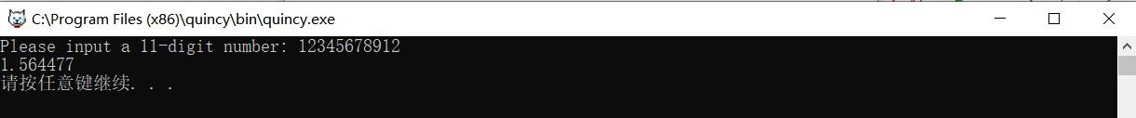Test result:1.564477

Test 2

Enter characters that are not Arabic numbers:

For example:1234567891a.

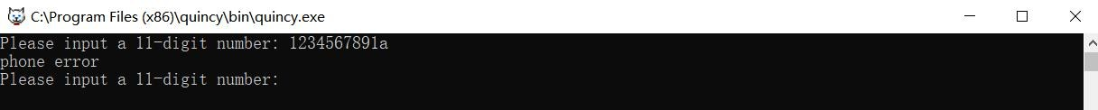Test result: Error and prompt to re-input

Test 3

Enter twelve digits： For example:123456789123. Test result: Error and prompt to re-input

Test 4

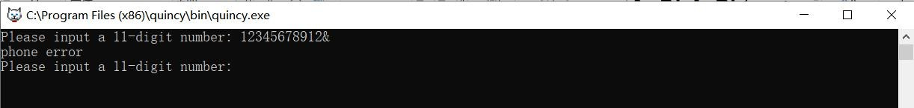Enter strange characters： For example:12345678912&. Test result: Error and prompt to re-input

Test 5

Enter twelve digits with a character which is not Arabic number ： For example:123456789123a.

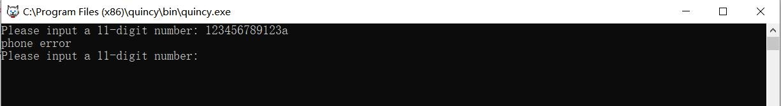Test result: Error and prompt to re-input

Test 6

Enter twelve digits with a character which is not Arabic number and strange characters： For example:123456789123a&.

Test result: Error and prompt to re-input



Test 7

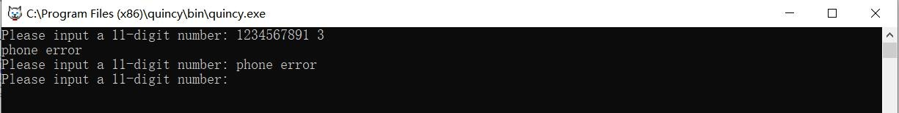Enter eleven digits with a space： For example:12345678912 3 Test result: Error and prompt to re-input

# Exercise 3

**Specification（Problem statement）:**

The task is to let the user enter three-digit positive numbers from the keyboard. Convert the integer number to its binary equivalent and print it on the screen (e.g. 212 = 11010100).Therefore, this program provides the following functions:

1. The user can enter three-digit positive integer numbers from the keyboard
2. After the user to enter the numbers,scanning each character and judge if it is Arabic number,an error is reported if the scan detects that the input is not an Arabic number. An error condition is as follows:

(1) The user enters non-three-digit positive integer numbers ,e.g.4444 The user enters numbers and other non-Arabic numbers，e.g.44a Space is added when the user enters a number,e.g.44 4

The user enters strange characters,e.g.&

1. The output result of the program is a series of numbers consisting of a 1 and a 0
2. The program exits.

**Analysis：**

The question asks the user to enter three-digit positive integer numbers, but

the user may enter the digits incorrectly, causing the program to fail. Therefore, it is necessary to consider how to solve this problem. The error reporting cases mainly include the above five points. It is necessary to judge whether the user has entered the correct number.The output result of the program is a series of numbers consisting of a 1 and 0.

**Flow chart :**

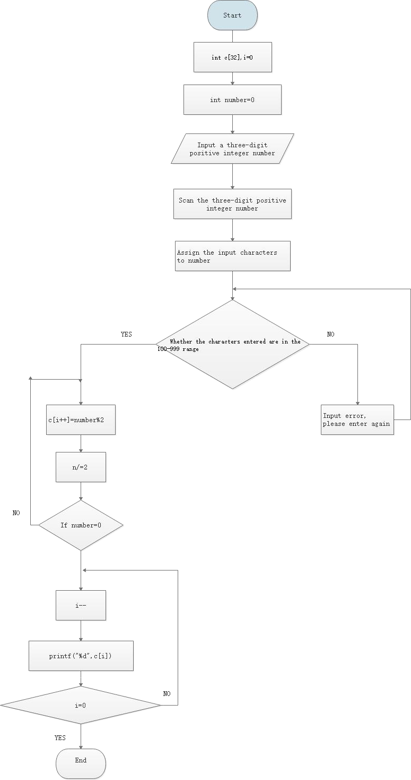

##### On an input:

The message “Please input three-digit positive integer numbers: ”is printed on the screen to let the users know what data this program need.

##### On Outputs:

The result is a decimal number converted to a binary number.The output is in positive integer form with 0 and 1.

##### Data structure:

The input data structure is three-digit positive integer numbers, and the output is positive integer,too.

##### Algorithm:

{

int c[32],i=0; do{ c[i++]=n%2;

n/=2;

}

while(n!=0); for(i--;i>=0;i--)

printf("%d",c[i]); printf("\n");

}

**Design**

* 1. Declare two variables : number=0,i=0(loop) and a array c[32]

Number-the number which user inputs i-Loop variable

Array -This array is needed when the decimal is converted to binary.

* 1. Print a message “print three-digit positive integer numbers: ”on the screen.
  2. Read the input real number from the keyboard .
  3. The program is terminated if the read fails. (The data type of the input data does not meet the data type specified).Print a message “Please enter three-digit positive integer numbers ：”on the screen to ask the user to input again.
  4. Calculate the remainder of the input number divided by 2. 6.Divide the number by 2.

7.Repeat the above steps until 0 or 1. 8.Display the result on the screen.

**Testing**

Test 1

Enter right characters that are three-digit positive integer numbers: For example:111.

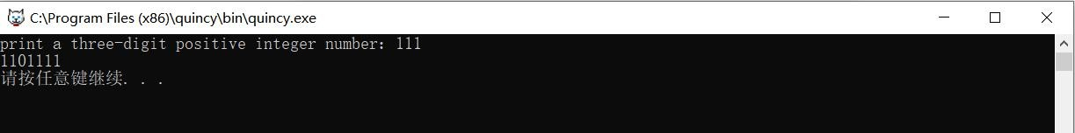Test result:1101111

Test 2

Enter right characters that are two-digit positive integer numbers and a character: For example:11a.

Test result:Error and prompt to re-input

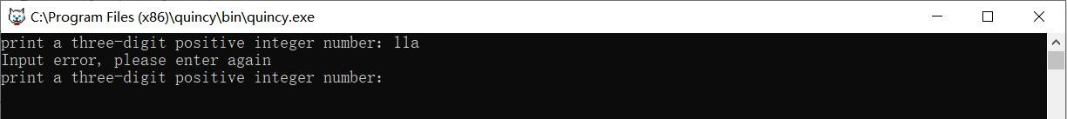

Test 3

Enter right characters that are two-digit positive integer numbers and a character: For example:1111.

Test result: Error and prompt to re-input

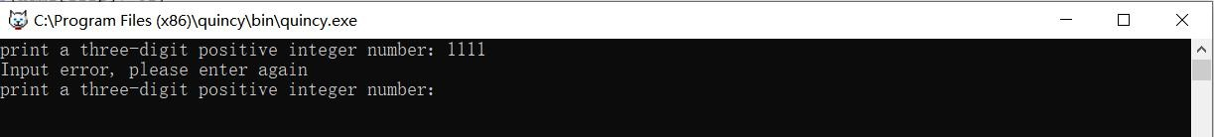

Test 4

Enter right characters that are two-digit positive integer numbers and a strange character: For example:11&.

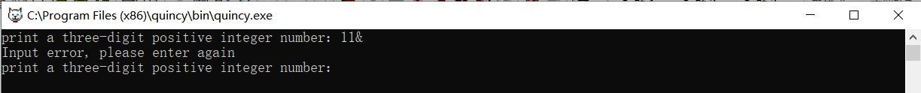Test result: Error and prompt to re-input

Test 5

Enter right characters that are three-digit positive integer numbers and a strange character: For example:111&.

Test result: 1101111

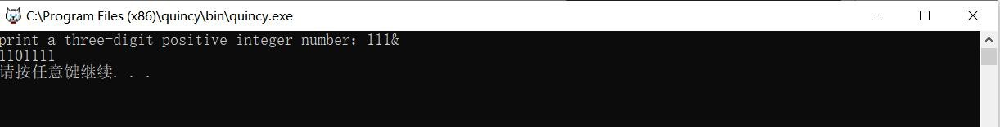Reason: The program recognizes only the first three digits

# Exercise 4

**Specification（Problem statement）:**

The requirement of the task is to provide the user with the choice of performing a two-dimensional rectangular to polar or polar to rectangular

coordinate conversion on vector

*A*=*Axi*  *Ay j*

.Displays the result on the

screen.Therefore,this program provides the following functions:

1. Users can choose from two functions (two-dimensional rectangular to polar or polar to rectangular coordinate conversion)
2. After the user selects the function, judge whether the user entered 1 or 2.If the user doesn't type 1 or 2, the program reports an error and asks the user to retype.An error condition is as follows:
3. The user the user doesn't type 1 or 2 ,e.g.3
4. The user enters letters and other non-Arabic numerals，e.g.a (3)The user enters strange character, e.g.&
5. If the user chooses the function 1,the result will be

** = tan-1 *Ay*

*A*



*A* = 、

*A* 2  *A* 2

*x y*

*Ax*

1. If the user chooses the function 2,the result will be



*Ay* = *A* sin(*A* )

1. The program exits.

**Analysis：**

*Ax* = *A* co（s

*A*）、

The question asks the user to two functions and input the corresponding number（ 1 or 2 ）, but the user may enter the number incorrectly, causing the program to fail. Therefore, it is necessary to consider how to solve this problem. The error reporting cases mainly include the above three points. It is necessary to judge whether the user has entered the correct number.The output data with

six decimal places will be determined by the user's choice.

**Flow chart :**

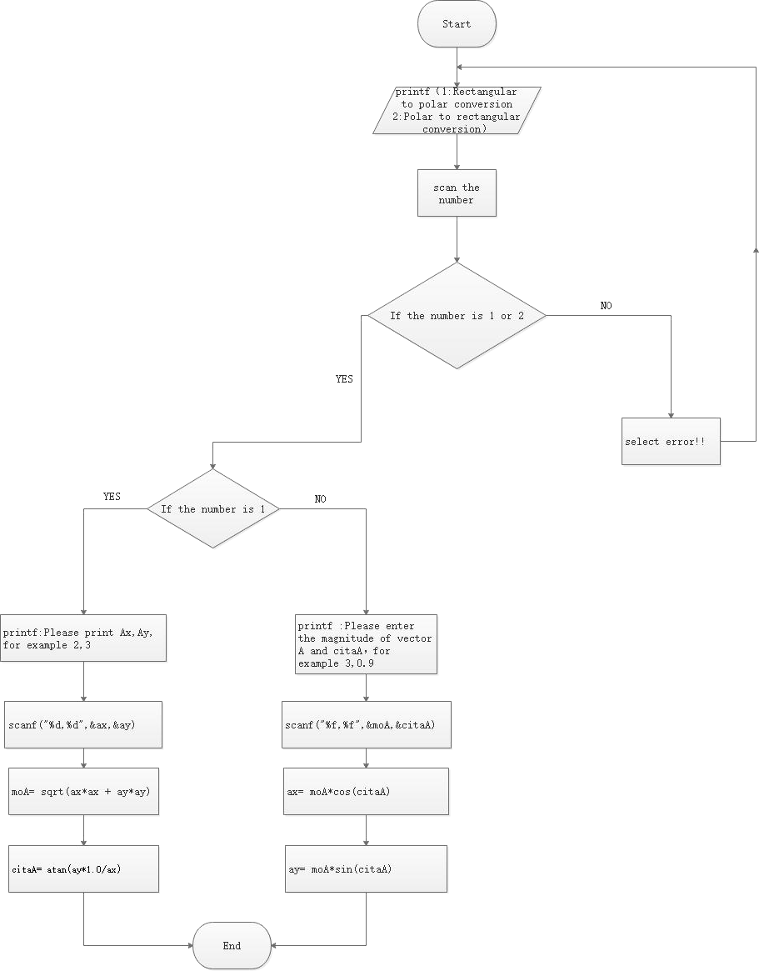

##### On an input:

The message “choose from two functions (two-dimensional rectangular to polar or polar to rectangular coordinate conversion)”is printed on the screen to let the users choose.

The user will enter 1 or 2.

##### On Outputs:

The result depends on what the user has entered.

If the user chooses the function 1,the result will be

** = tan-1 *Ay*

*A*



*A* = 、

*A* 2  *A* 2

*x y*

*Ax*

If the user chooses the function 2,the result will be



*Ay* = *A* sin(*A* )

*Ax* = *A* co（s

*A*）、

##### Data structure:

The input data structure is 1 or 2, and The result depends on the functionality the user selects.

##### Algorithm:

switch(select){ case 1:

printf("Please print Ax,Ay, for example 2,3:\n"); scanf("%d,%d",&ax,&ay); printf("Ax=%d,Ay=%d\n",ax,ay);

moA= sqrt(ax*ax + ay*ay); printf("moA=%f\n",moA); printf("ay/ax=%f\n",ay*1.0/ax); citaA= atan(ay*1.0/ax); printf("citaA=%f\n",citaA); break;

case 2:

printf("Please enter the magnitude of vector A and citaA ， for example 3,0.9:\n");

scanf("%f,%f",&moA,&citaA); printf("moA=%f,citaA=%f\n",moA,citaA); ax= moA*cos(citaA);

ay= moA*sin(citaA); printf("Ax=%f,Ay=%f\n",ax,ay);

break;

default: break;/*stop

**Design**

I:

II:

Declare four variables : int ax=0, ay=0;float moA=0, citaA=0; ax=0-Abscissa

ay=0-ordinate moA-module citaA-Angle

Determine if the user entered 1 or 2,report an error if not and ask the user to retype

III:

##### If the user chooses function 1:

1.Print a message “Please print Ax,Ay, for example 2,3: ”on the screen. moA= sqrt(ax*ax + ay*ay)

citaA= atan(ay*1.0/ax)

##### If the user chooses function 2:

Please enter the magnitude of vector A and citaA，for example 3,0.9 ax= moA*cos(citaA)

ay= moA*sin(citaA) IV:

Display the result on the screen.

**Testing**

Test 1

Enter right number that is 1 and next enter 2,3 Test result:moA=3.605551

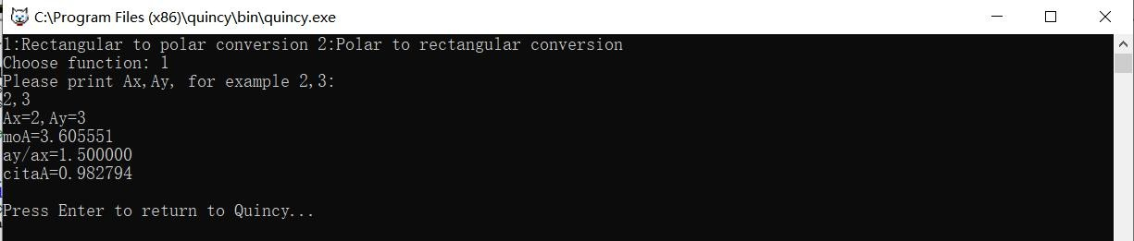Ay/ax=1500000 citaA=0.982794

Test 2

Enter right number that is 2 and next enter 3,0.9 Test result: moA=3.000000

Ay=0.900000 Ax=0.000000

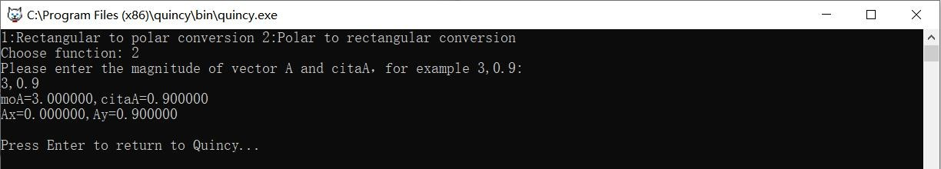citaA=0.900000

Test 3

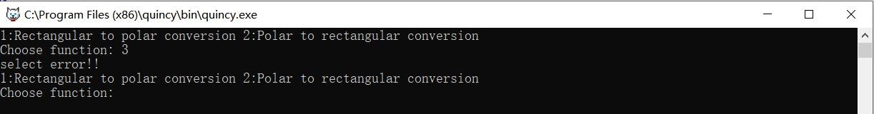Enter wrong number 3 Test result:select error!

Test 4

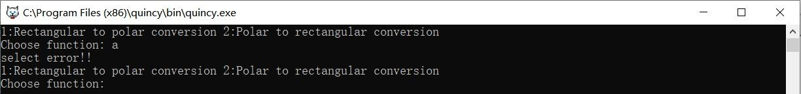Enter wrong character a Test result:select error!

Test 5

Enter strange character, e.g.& Test result:select error!

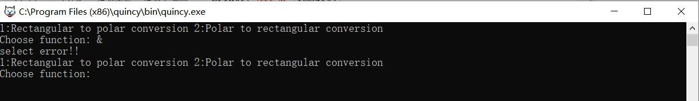

**Implementation Tiankuo.Jiao 1929098**